BRAZILIAN INITIATIVE ON PRECISION MEDICINE (BIPMED): THE FIRST PUBLICALLY AVAILABLE GENOMIC DATABASE IN LATIN AMERICA
C. S. Rocha¹, B. S. Carvalho², I. Lopes-Cendes¹ * for the BIPMed Collaborative Group
¹ Department of Medical Genetics, School of Medical Sciences, ²Department of Statistics, Institute of Mathematics, Statistics and Scientific Computing; University of Campinas – UNICAMP and the Brazilian Institute of Neuroscience and Neurotechnology, Campinas, SP, BRAZIL

Introduction: BIPMed is an initiative of five Research Innovation and Dissemination Centers (RIDCs): The Brazilian Research Institute for Neuroscience and Neurotechnology (BRAINN), Center for Computational Science and Engineering (CCES); Center for Research in Cell Therapy (CTC); Obesity and Comorbidities Research Center (OCRC); and Center for Research on Inflammatory Diseases (CRID). Precision Medicine has emerged recently as a concept in which scientific knowledge and technology will come together to provide the basis for the 21st century medicine. It involves translational research, genomics and personalized medicine to propose a new data integration level to improve health care. The database was created from the need to have genetic information from the Brazilian population and make this information public available.

Materials and Methods: BIPMed is based initially on a software platform, the Leiden Open Variation Database¹, it is a fully web-based gene sequence variation database, which is platform-independent and uses PHP and MySQL open source software. The design of the database follows the recommendations of the Human Genome Variation Society (HGVS) and focuses on the collection and display of DNA sequence variations. BIPMed fallows the guidelines and principles of the Global Alliance for Genomics and Health (http://genomicsandhealth.org/) observing the responsible sharing of genomic and clinical data. It has two levels of access, the open access that doesn’t need registration nor identification, and the restrict access which allow access to individualized information of the deposited variants.

Results: At the moment the database is filled with variants detected using Illumina Nextera Expanded Exome from 29 Brazilian Reference individuals, with 20842 genes and more than ten million variants. (Figure 1)
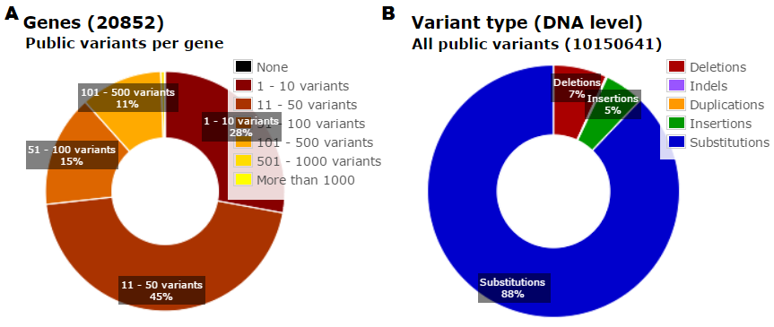
Figure 1: A - percentage of number of variants in genes; B – percentage of variation type

Discussion and conclusion: The database is one of the first steps of the Brazilian Initiative on Precision Medicine, its objective is to provide an interface that allow responsible and safe sharing of genomic and clinical data. We expect the database to grow and include data-sets from specific diseases, as well as other types of data such as transcriptomes and proteomes. This platform is the first of its kind in Latin America and is intended to be used by clinicians and scientists all over the world, to share and obtain information about various aspects of genomic medicine and human health, as well as to support dissemination and training.

References: [1] Fokkema IF, Taschner PE, Schaafsma GC, Celli J, Laros JF, den Dunnen JT (2011). LOVD v.2.0: the next generation in gene variant databases. Hum Mutat. 2011 May;32(5):557-63.

