The Use of Dyneema Fiber Phantom for DTI Quality Control: Influence of Imaging Acquisition Parameters on DTI Indexes

E. M. Souza^{1,2}, E. T. Costa^{1,2}, G. Castellano³

¹Biomedical Engineering Department, FEEC, UNICAMP, Campinas, Brazil
²Biomedical Engineering Center, UNICAMP, Campinas, Brazil
³Neurophysics Group, IFGW, UNICAMP, Campinas, Brazil

Introduction: Diffusion tensor images (DTI) have many applications in neurology. However, the measured signal is susceptible to the influence of noise and artifacts, being thus important to check if these factors do not compromise the parameters calculated from the images. Given that there are no standard routines for quality control (QC) of these images, the main goal of this study is to propose a fiber phantom for DTI QC. In this work we present a three bundles Dyneema fiber phantom for routine DTI QC and evaluate the stability of its DTI indexes when the acquisition parameters change at the 3T Philips Achieva MRI scanner of the Medical Sciences School of UNICAMP.

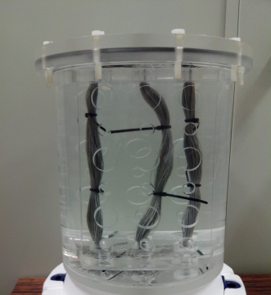
Materials and Methods: The DTI phantom (see figure) consists of a rectangular insert containing3 parallel Dyneema [1] fiber bundles (130 fibers of 0.40 mm diameter, 150 fibers of 0.35 mm and 200 fibers of 0.25 mm). The insert is placed inside a cylinder filled by distilled water.DTI were acquired using a 8 channel head coil, with a standard (clinical) spin-echo pulse sequence. We acquired DTI using 7 different b-values, 6 echo times (TE) and 5 voxel dimensions, one one parameter changed at a time. The detection of imaging outliers and DTI processing were done using ExploreDTI (www.exploredti.com) and Matlab software. We evaluated the stability of the fiber phantom by estimation of coefficients of variation (CV) for fractional anisotropy (FA), apparent diffusion coefficient (ADC), relative anisotropy (RA) and volume ratio(VR) for each bundle, for each parameter changed.

Results: We observed that from all DTI indexes calculated and pulse sequence parameters changed, the higher CV found was 0.23 for RA, obtained for the bundle of fibers of 0.35 mm, when the voxel size changed. For ADC and FA, the CV ranges were (0,02 - 0,18) and (0,02 - 0,21), respectively, considering all fiber bundles. The highest CV of these parameters were also found for the bundle of fibers of 0.35 mm, when TE or voxel size changed. For RA and VR the CV ranges were (0,02 - 0,23) and (0,002 - 0,07), respectively. For VR, the higher CV found was 0,07, also for the bundle of fibers of 0.35 mm when the voxel size changed.

Discussion: The results obtained show that, for all bundles, there is no significant variation on DTI index values obtained when the pulse sequence parameters are changed one-at-a-time. These findings suggest that Dyneema fibers can be useful for building of stable and low-cost DTI phantoms. The highest CVs found were for the bundle of fibers of 0.35 mm. They might occur because of some compression differences between the bundles, which must be corrected for future essays.

Conclusion: The findings suggest that the phantom developed could be useful for DTI QC. However, other pulse sequence parameters must be studied, as well as different MRI head coils. The compression of fiber bundles has to be improved to upgrade phantom stability and FA values, making the setup closer to the main axon tracts.

References:[1] Fieremans E, Deene ED, Delputte S, et al. J Magn Res 190: 189-199, 2008.

