Resting-state networks and brain connectivity in elderly patients with asymptomatic unilateral internal carotid artery stenosis

P.H. R. da Silva¹, A.P.A. Camargo², O.M. Pontes-Neto², R.F. Leoni¹

¹Department of Physics, FFCLRP, USP, Ribeirão Preto, Brazil
²Department of Neurosciences and Behavioral Science, FMRP, USP, Ribeirão Preto, Brazil

Introduction: Asymptomatic unilateral internal carotid stenosis has been associated with brain hemodynamic changes and cognitive impairment [1]. However, the effects on brain functional connectivity is not totally clear. Therefore, the present study aims to assess changes in functional connectivity and their relation to cognitive decline in a group of patients at presymptomatic stage.

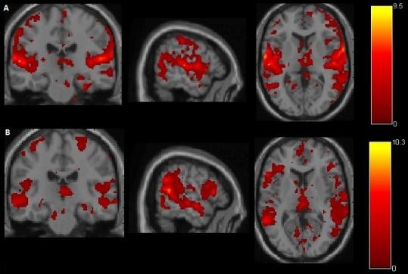
Materials and Methods: Two elderly patients with asymptomatic stenosis of the right internal carotid artery and three healthy elderly volunteers participated in this study. All participants read and signed an informed consent approved by the Ethics in Research Committee of the Clinical Hospital of Ribeirao Preto (HCFMRP) before participating in the study. Experiments were performed on a 3T Philips Achieva System (Philips Achieva, The Netherlands), using 32-channel head coil reception and body coil transmission. BOLD-fMRI images were acquired at resting state using a 2D EPI sequence with the following parameters: TR/TE = 2000/30 ms, excitation angle = 90°, number of slices = 31, slice thickness = 4 mm, interval between slices (gap) = 0.5 mm, number of repetitions = 320. For anatomic reference, images were acquired using a T1-weighted GE sequence with the following parameters: TR/TE = 7/3.1 ms, excitation angle = 8°, FOV = 240 x 240 mm², number of slices = 160, slice thickness = 1 mm. Resting state networks were assessed using Independent Component Analysis (ICA) with GIFT GROUP-ICA and functional connectivity were studied by graph analysis using CONN, Brain Connectivity Toolbox and Connectome Viewer toolboxes.

Results: Compared with controls, patients showed marked changes in cluster size of some resting state networks in group and individual analysis. As an example, figure 1 shows the auditory network for both groups. Moreover, graph analysis showed “degree” and “global efficiency” impairment in the hemisphere ipsilateral to the stenosis. However, data from more patients has to be used in graph analysis to get results that are more robust.
Figure 1: Auditory network of the (A) healthy control and (b) patient groups.

Discussion: Even at presymptomatic stage, compromised resting state networks are probably due to the presence of unilateral carotid stenosis [1, 2], which causes impairment in cerebral hemodynamics and, likely, disruption of ipsilateral hemisphere connectivity [3].

Conclusion: The present study confirmed abnormalities in resting state networks in patients with asymptomatic unilateral carotid stenosis, showing that brain connectivity may provide additional information to predict cases at risk of brain ischemia. The next steps of the study include the analysis of more patients’ data and the assessment of the relationship between brain connectivity impairment and cognitive decline.

References: [1] Lin C.J., et al. Connectivity features for identifying cognitive impairment in presymptomatic carotid stenosis. PLoS ONE 9(1):e85441, 2014. [2] Cheng, H.L., et al. Impairments in cognitive function and brain connectivity in severe asymptomatic carotid stenosis. Stroke 43:2567-2573, 2012. [3] Ting-Yu, C., et al. Graph theoretical analysis of functional networks and its relationship to cognitive decline in patients with carotid stenosis. J Cereb Blood Flow Metab Oct. 1, 2015.

