Generalized Epilepsies And Persistent Seizures: Clinical And Neuroimaging Features
M.K.M. Alvim¹, M.S. Polydoro², D.S. Garcia², M.E. Morita¹, C.A.M. Guerreiro¹, F. Cendes¹, C.L. Yasuda¹
¹Neurology Dept. University of Campinas, ² University of Campinas

Introduction: Idiopathic generalized epilepsies (IGE) are usually associated with good response to antiepileptic drugs and normal brain MRI. Recent studies have demonstrated structural and functional alterations in these patients, without noticing differences between seizure-free and patients with persistent seizures¹.
Objective: To compare clinical and MRI differences in IGE patients with and without seizure control.
Methods: We consecutively recruited 40 IGE patients (25 women, 33± 10 years) and 118 healthy controls, paired for age and gender. Patients were classified as seizure free (SZ-free, 21 subjects) or refractory seizures (SZ-refr,19 subjects). All subjects underwent high-resolution T1 weighted images scan on 3T MR device. Images were automatically parcellated with Freesurfer 5.3. We compared cortical and subcortical volumes between patients and controls. In a subsequent analysis we searched for differences between patients with and without seizures.
Results: After covarying MANOVA for intracranial volume, IGE group presented reduced volume of subcortical grey matter (p<0.05), but not of white matter or cortical GM volume. Cortical thickness was thinner in right precentral gyrus and left paracentral area. The thalamus volume is indicated in figure 1. Clinically, SZ-free and SZ-ref groups were balanced for gender, age, age of onset and occurrence of absence seizures. A preliminary analysis with logistic regression (SZ-free x SZ-refr) suggested that presence of myoclonus was associated with persistent seizures (p=0.017).
Discussion: Our results indicate that some IGE patients persist with seizures despite medication, even with polytherapy. These preliminary analyses suggest that thalamic volume is reduced in controlled patients, who also present less myoclonus than patients with seizures. Further analyses with white matter and functional connectivity may add information about factors related to differences in seizure control.
Charge 1 Charge 2

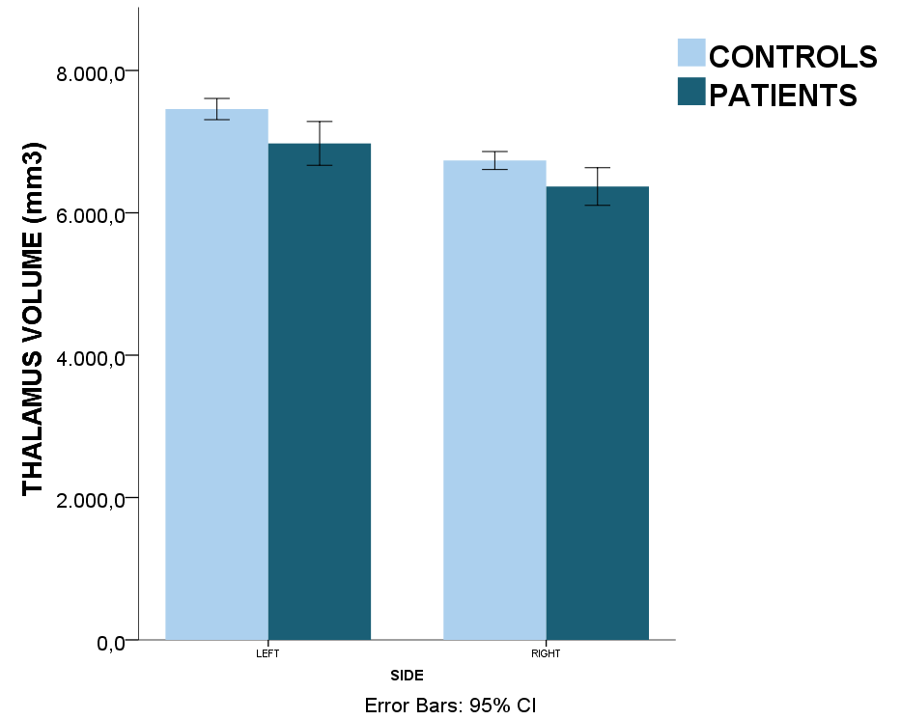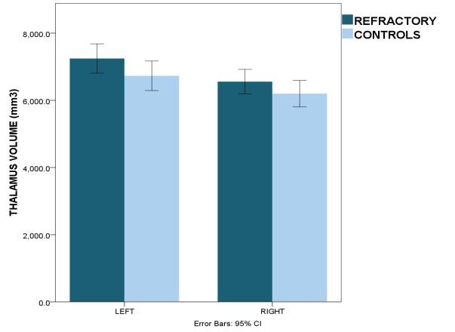

Charge 1 – Controls and Patients Thalamic volumes
Charge 2 – Controls and Refractory patients Thalamic volumes

[1] Koepp MJ et al., Expert Rev Neurother 14 (7): 819-831, 2014.

