Stories and images on epilepsy

C.F.S.Toneloto ^{1,2}, S.A.Adestro ², L.M.Li^{2,3,4}
¹ Collective Health Dept., FCM, UNICAMP; ²ASPE; ³ Neurology Dept., FCM, UNICAMP; ⁴ BRAINN.

Introduction: The writer Eduardo Galeano said "We are not made of atoms, but stories." Storytelling is an interesting and enjoyable activity, and to some extent 'therapeutic', both for those who share their stories as well for those who listen it. This is a powerful way to convey new meaning to epilepsy, often perceived in negative and prejudicial manner by the society. People with epilepsy have over the century endured isolation, and the word Epilepsy has been cast away, and expression has not been always easy. A saying “A photo is worth a thousand words” portraits the perspective and the message in many ways. The possibility to start a dialogue by the patients and families to others appeared for us like an important way to dispel the myths and stigma of epilepsy.
Objective: to promote discussion on epilepsy using written (narrative), and iconic (photographic) media to provoke reflections about epilepsy.
Material and Method: We used social media as platform for interactions with people with epilepsy and to invite them to share their stories since 2014. In addition, we promote two photograph contest “How do I see Epilepsy”, one in 2014 and other in 2015 using Facebook for upload of image with public voting, as well as a panel of judge.
Results: We received 6 articles in 2014 and were compiled into and e-book published on February 9, 2015, on the occasion of the first International Day for Epilepsy. These were stories of people with epilepsy and their families: "The story of Daniel" (by Joberto and Eric Yoshida de Freitas), "The Letter of Carolina "(by Carolina Correia)," My life with Epilepsy "(by Nívia Colin)," Love: the essence of healing "(by Clarinda Lima)," The history of Arlen "(by Ellen Aparecida da Silva), and" The story of Marcela and Milena "(by Rosemari Coradin). The 2014 Photograph Contest received 12 photos and 15 in 2015. These were presented in public exhibition during the National Epilepsy Awareness Week on September 9, and were printed in a booklet and a calendar.
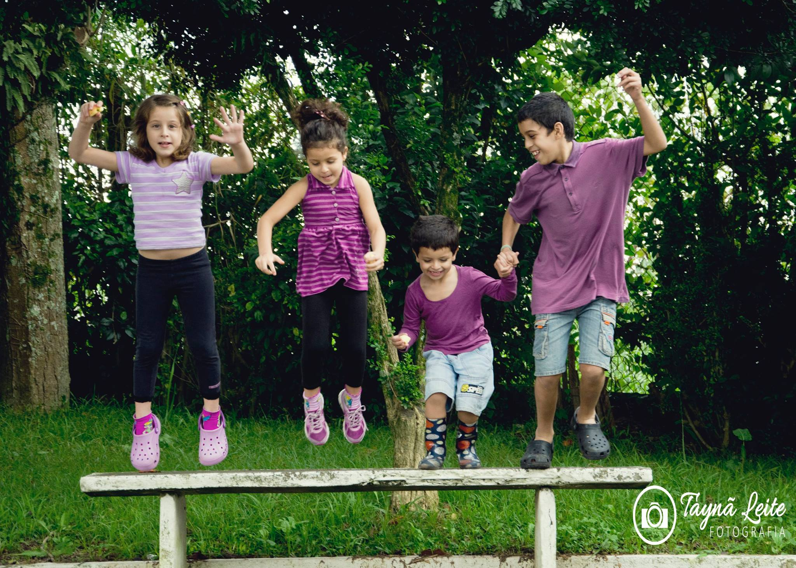

Purple day, purple way by Priscilla Carbone, winner 2014 | Love, unity, inclusion...a jump against prejudice by Tayna Leite, winner 2015

Discussion:
The six narratives of people with epilepsy are indicative and representative of the personal coping processes with this disease. Also the photographs showed different views in distinct social and family contexts. Within this objective, the electronic-book "Olhares sobre a Epilepsia[1]" was originally designed.
Conclusion: The voice of people with epilepsy and their families were heard through e-book, creating new perspectives about this illness experience. Other voices, represented by the images participants of the photographic competition summed up to the mosaic, breaking the single story culture. This showed alternative ways of conceiving, and to represent, the epilepsy, improving reflections about the impacts of this complex disease.
___
[1] Li,M.,Toneloto,CFS, Adestro,S.Olhares sobre a Epilepsia [e-book].Campinas: ADCiência Divulgação Científica; 2015 [access 10 mar.2016]. Available at: http://issuu.com/adciencia/docs/livroolharessobreepilepsia_0560acd2b06e99

