Worse cognitive performance is associated to Default Mode Network abnormalities in ischemic stroke

J. E. Vicentini¹, B.M. Campos¹, S.R.M. Almeida¹, L. Valler¹, L. M. Li¹
¹ Neurology Dept., FCM, UNICAMP

Introduction: One-third of patients that suffered a stroke will face cognitive decline, which negatively impacts outcome¹. Resting-state functional connectivity is defined as temporal correlation between spatially remote regions of brain². The Default Mode Network (DMN) is one of most prominent resting-state functional network and it has been associated to cognitive and emotional processing. We aimed to investigate whether resting state functional connectivity of DMN was associated to cognitive performance in stroke patients.
Materials and Methods: The present study was approved by ethics committee and all individuals gave written informed consent for their participation. Thirty-four subacute (less than one month from the ictus) stroke patients aged between 45-80 who had experienced their first-ever ischemia and without previous neurological history were submitted to: 1) neuropsychological evaluation through Montreal Cognitive Assessment (MoCA) and 2) functional Magnetic Resonance Imaging (fMRI) acquisition using a 3T scanner (Philips Achieva®). The image processing were based on realignment, segmentation, normalization (MNI-152) and smoothing, using UF²C (User Friendly Functional Connectivity) toolbox. One-way analysis of variance was performed in SPM12 for MATLAB, adjusting for gender, age, educational level and Fazekas score and following the parameters of p<0.001 uncorrected and cluster size with at least 50 voxels.
Results: We found a negative correlation between MoCA scores and DMN functional connectivity in left middle frontal gyrus and left inferior parietal gyrus (table 1 and figure 1), suggesting that worse cognitive performance is related to increased functional connectivity of DMN core areas.
Table 1 Coordinates and cluster size of negatively correlated area between MoCA scores and DMN functional connectivity (p<0.001, uncorrected)
 |  | Stereotaxic coordinates (mm)
Cluster size | Region | X | Y | Z | T value | Z value
67 | Left middle frontal gyrus | -40 | 48 | 10 | 4.35 | 3.80
66 | Left inferior parietal gyrus | -48 | -52 | 56 | 4.20 | 3.69
Figure 1 Correlation results between MoCA scores and DMN functional connectivity (p<0.001, uncorrected)
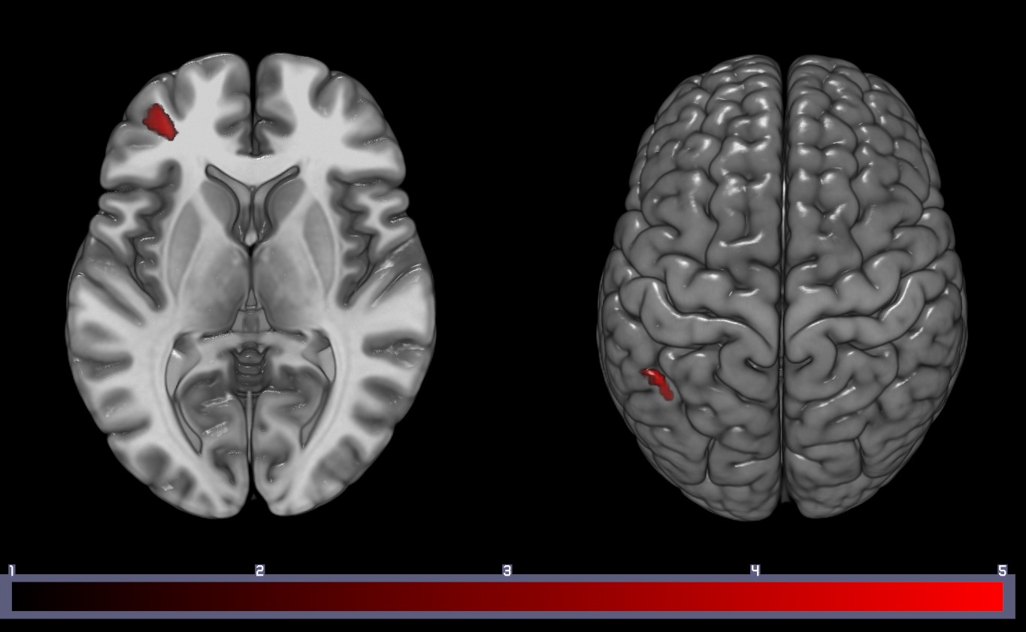
Discussion: Previous studies indicate that DMN plays an important role in cognitive impairment³. Deactivation of key nodes of the DMN may be a prerequisite for focused attention and successful memory encoding⁴. However, the increased DMN functional connectivity suggests failure to suppress activity in some of the core DMN in cognition, which in turn is associated with worse performance in MoCA scores⁵.
Conclusion: Abnormal DMN was associated with worse cognitive performance following stroke in subacute stage. Our findings may be helpful for facilitating further understanding of the potential mechanism underlying post stroke cognitive performance.
References: [1] Pohjasvaara T et al., Cerebrovasc Dis 14 (2): 228-233, 2002; Raichle ME et al., PNAS 98 (2): 676-682, 2001; [3] Greicius et al., PNAS 101 (13): 4637-4642, 2004 [4] Miller SL et al., PNAS 105 (): 2181-2186, 2008; [5] Grady CL et al., Cogn Neurosci 18(2): 227-241, 2006.

