Automatic Generation of International 10-20 System for Electrode Placement
J. A. I. Rubianes Silva¹, S. T. Wu¹
¹School of Electrical and Computer Engineering, FEEC, UNICAMP

Introduction: Focal cortical dysplasia (FCD) is a malformation of cortical development. It’s closely related to pharmacoresistant epilepsy. Its diagnosis is based on medical history, histological, imaging and electrophysiological evidences. The presence of spikes and sharp waves on a routine electroencephalogram (EEG) is a strong evidence of seizure focus. Because of the variability of cortical landmarks underlying electrode positions [1], correlating scalp electrodes with cerebral structures may improve the identification of cortical generators of epileptiform potentials. Our main goal is to co-localize electrophysiological signals with other functional and anatomical data for better supporting dicision-making on a diagnosis of FCD. In this work we present a novel GPU-based algorithm for generating the electrode positions from the external anatomical landmarks according to the international 10-20 and 10-10 systems (Fig. 1) [2] and for visualizing them with respect to the underlying gyral and sulcal convolutions.

Materials and Methods: Five anatomical landmarks, nasion (N), inion (I), a midline point (M), left (A1) and right pre-auricular (A2), are input by an expert through a pointing device. From N, I and M a mid-plane is defined and the voxels above a specified threshold in this plane are segmented with a GPU-based threshold technique (Fig. 2). After filling the white holes, a piecewise linear curve from inion and nasion is segmented by a gradient-based method (Fig. 3). If it’s a 10-20 system, the curve is partitioned in 10%, 20%, 20% 20%, 20%, 10% from N to I at the Fpz, Fz, Cz Pz and Oz, respectively. The process is repeated with the plane A1CzA2 for getting T3, C3, C4 and T4. Then the planes IT3N, IT4N are constructed and the segmentation steps repeated for getting positions F7, F8, T5 and T6; and again with the planes F7FzF8 and T5PzT6 for computing F3, F4, P3 and P4. The positions labeled with the corresponding identifications are opaquely rendered, whereas the tissue surrounding the brain is rendered at lower opacity, as shown in Fig. 4. Following the same reasoning, we implemented the 10-10 system. We have evaluated our algorithm with MRI volumes acquired by a MR 3T Philips Intera-Achieva Scanner.

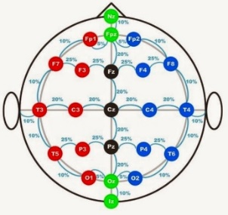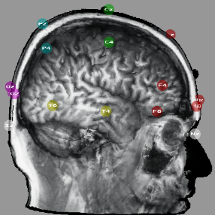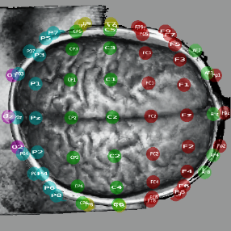
(2)
(1)
(3)
(4)
(5)

Result: Fig. 5 presents the visualization of the 10-10 system. Note that the transparent skull and the electrode location rendering allow us to easily assess the spatial relationship between the electrode position on the scalp and the underlying cortical structure even when the number of electrodes increases from 10-20 to the 10-10 system.

Discussion and Conclusion: By reducing a 3D placement to a 2D placement problem, simple well-known image processing algorithms are directly applicable. In addition, we explore GPU processing capabilities to make the procedure interactive. Nevertheless, despite visually convincing results, it is necessary to validate numerically the generated positions.

References: [1] Richard W Homan, John Herman, Phillip Purdy, Cerebral location of international 10–20 system electrode placement, Electroencephalography and Clinical Neurophysiology, Volume 66, Issue 4, April 1987, Pages 376-382, ISSN 0013-4694, http://dx.doi.org/10.1016/0013-4694(87)90206-9; [2] TransCranial Technologies. 10/20 System Positioning Manual. https://www.trans-cranial.com/local/manuals/10_20_pos_man_v1_0_pdf.pdf

