Epilepsy: behind the white matter involvement

R. A. Natal¹, F. Rogério², F. Cendes³, I. Lopes-Cendes⁴
¹ Laboratory of Investigative Pathology (CIPED); ² Department of Pathology; ³ Department of Neurology; ⁴ Department of Medical Genetics –School of Medical Sciences, University of Campinas – UNICAMP, SP, Brazil

Introduction: Among the major neurological disorders, epilepsy is one of the main conditions. About 1% of people worldwide (around 65 million) have epilepsy. The pivotal pathophysiology is determined by changes in neurons behavior in specific regions of the brain, resulting in recurrent seizures [1]. However, recent neuroimaging studies indicate that white matter is altered in epilepsy as well, but its meaning remains unknown. It is known that after white matter injury, expression of Dishevelled Associated Activator of Morphogenesis 2 (Daam2) inhibits oligodendrocyte differentiation, precluding neuron remyelination [2]. In this context, the aim of this study is to evaluate Daam2 expression in epileptic and non-epileptic brain.

Materials and Methods: Formalin-fixed and paraffin-embedded (FFPE) sections of temporal lobe of autopsy specimen (control, n= 1) and surgical specimen of patient with mesial temporal lobe epilepsy (case, n= 1), who had undergone surgery for refractory seizures were evaluated using immunohistochemistry. Sections were deparaffinized, rehydrated and submitted to antigen retrieval (citrate pH 6.0). The primary antibody Daam2 (Sigma, MO, St. Louis, USA) was applied at 1:50 dilution. ADVANCETM (Dako, CA, Santa Clara, USA) was used to detect primary antibody. The evaluation of immunohistochemical results was performed by an experienced neuropathologist (FR).

Results: In the hematoxylin and eosin slices we did not observe any differences between case and control tissue. In Daam2 immunohistochemical analysis, both case and control tissue did not show Daam2 expression in gray matter. However, we observed that patient tissue had an unspecific higher expression of Daam2 in white matter when compared to control (Figure 1A and B). Interestingly, some neurons presented Daam2 expression in both case and control tissue (Figure 1C).

Discussion: We are reporting on preliminary results; therefore, additional samples will be analyzed. Daam2 regulates Wnt pathway by direct PIP5K modulation. After injuries, increased expression of Daam2 determines inhibition of oligodendrocytes differentiation, and is responsible to reduced neuron remyalination. Thus, recurrent seizures could be a pivotal trigger to induce Daam2 expression causing further tissue damage by inhibiting remyelination of the affected region after seizure- induced damage.

Conclusion: Daam2 signaling (Wnt pathway) could be involved in white matter damage in epilepsy.

References: [1] Thurman DJ et al., Epilepsia 52(7): 2-26, 2011; [2] Lee HK et al., Neuron 85(6): 1227-43, 2015;

A 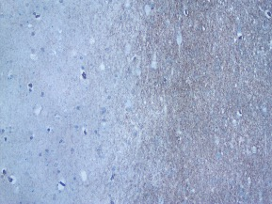 B 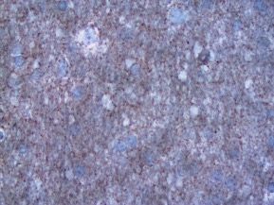 C 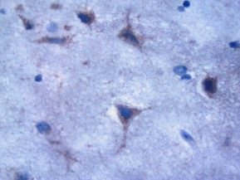
Figure 1: Surgical specimens of patients with mesial temporal lobe epilepsy: (A) represents the transition between gray matter (left), with no expression of Daam2, and white matter (right), with expression of Daam2 (100x); (B) represents a zoom in white matter with unspecific Daam2 reaction (400x); and (C) represents neurons with expression of Daam2 (400x).

