Thalamic volumes in different age groups

A. F. B. Camargo, L. M. Li, D. S. F. Magalhães
Neuroimaging Laboratory, Dept. of Neurology at FCM, UNICAMP

Introduction: The volumetric brain study may provide information about anatomy of underlying pathological processes. Therefore, proper study of thalamus, deep structure involved in reception and transmission of information in the brain is important to understand the clinical manifestation of diseases such epilepsy, stroke as well as neurodegenerative processes, which may occur in different ages. Thus, we performed the segmentation and volumetric measurement of thalamus on magnetic resonance images (MRI) of healthy subjects in three age groups, in order to identify an average volume for each age studied.
Materials and Methods: Segmentation of thalami was manually performed using the MRIcron software on T1 volumetric isotropic 1mm voxel brain imaging acquired from healthy individuals in a 3T MRI (Phillips, Achieva, Holland) from a brain imaging data bank. We studied 90 subjects (45 women), equally divided into 3 age groups: Group A, mean age 16,5 (range from 12 to 20); Group B, mean age 33,7 (range from 30 to 40); and Group C, mean age 60,7 (range from 50 to 90). We used Atlas [1] as reference for thalamus segmentation.
Results: The results for thalami segmentation for each group are shown in Table 1.
Table 1 – Thalamic volumes in mm³ mean (SD) from manual segmentation for each group of control MRI
Group A |  | Group B |  | Group C
Left | Right | Left | Right | Left | Right
4646,3 (226,8) | 4609,2 (278,1) | 5585,7 (183,1) | 5543,7 (203,1) | 4372,1 (240,3) | 4333,8 (203,8)
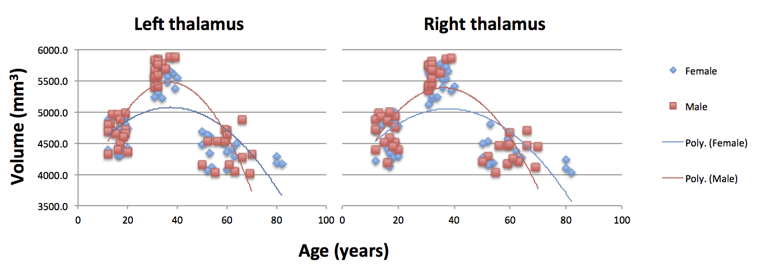
Discussion: MRI studies demonstrated the changes undergone by the human brain during childhood and adolescence [2], so that lower volumes achieved in the Group A, compared to Group B, for example, can be explained by the age of the subjects. Similarly, Group C also showed a smaller volumes. It’s known that normal aging reduces the volume of both grey matter and white matter of the brain, and this process is accelerated from the sixth decade of life [3], when the brain parenchyma shrinks as the ventricles increase [4]. The thalamus is associated with cognitive agility and is affected by atrophy more than other brain areas [2]. Full maturation of the brain has been described to take place after adolescence [2], which is supported by our finding.
Conclusion: The volumetric analysis of healthy subjects MRI in different age groups plays an important role in the study of relevant concepts to normal brain development and aging effects on thalamic structure. This can be used to study cognitive decline, as well as in diagnosis, surgical planning and following of certain neurological diseases involving the thalamus.
Acknoledgement: A. F. B. Camargo is recipient of FAPESP Scholarship 2015/04273-7.
References: [1] Lucerna S et al., Springer, 2002; [2] Cao B et al., NeuroImage 117:311-318, 2015; [3] Bozzali M et al., Magnetic Resonance Imaging, 26:1065-1070, 2008; [4] Kodiweera C et al., NeuroImage 128:180-192, 2016.

