Texture analysis of normal appearing white matter in atherosclerosis patients
Mariana Leite¹, Marina Saluzzi², Richard Frayne², Roberto Lotufo¹, Letícia Rittner^{1,}
¹ School of Electrical Engineering, FEEC, UNICAMP, ²Calgary Image Processing and Analysis Centre, University of Calgary/Foothills Medical Centre, Canada

Introduction: White matter is a complex structure that connects the grey matter regions of the brain. This structure is not uniform and presents variation in the MR signal intensity [1]. Patients diagnosed with atherosclerosis present lesions in the white matter called white matter lesions (WML). The regions within the white matter that does not present WML are called normal appearing white matter (NAWM), and the analysis of their variability is relevant in the disease diagnosis and therapy monitoring [2]. This work aims to compare the degree of discrimination of texture descriptors extracted from NAWM regions with varying location and size to distinguish normal from pathological white matter.

Materials and Methods: T2-weighted brain MR images from 61 atherosclerosis patients were acquired in three different sites. Two sites used the same MRI scanner (3T Discovery 750, GE Healthcare) and MRI acquisition parameters (TE 141.108ms, TR 9700ms, slice thickness 3mm); while images from the last site (3T Achieva, Philips Medical Systems) used similar acquisition parameters (except TE 125ms and TR 9000ms). WML regions were segmented by using a semi-automatic tool (Cerebra-WML [3]), while NAWM were automatically selected at three locations: in the contralateral hemisphere to the WML region, closest to the WML region and farthest away from the WML region. We also varied the NAWM size, ranging from 2x to 5x the size of the matching WML region (Fig. 1). From each region, texture descriptors were computed using the histogram, gradient, co-occurrence matrix and run length matrix [4]. Finally, a linear discriminant analysis (LDA) classifier [6] was used to evaluate the discriminating ability of the texture descriptors.

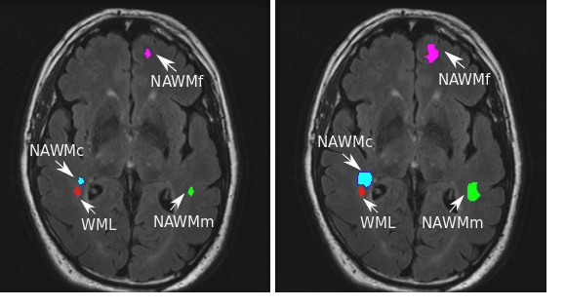
Results and Discussion: Similar accuracy rates were achieved when using the LDA classifier for regions of the same size, even when varying the NAWM region location. But lower accuracy rates were achieved when increasing NAWM region size (Table 1). The consistently lower accuracy for larger NAWM regions may be due to the increasing difference between regions containing WML and larger NAWM regions, making the classification task easier, and thus less robust to new samples: a case of over-fitting. Besides, larger NAWM regions may contain different structures, generating samples with lower discrimination capability.
Figure 1: WML (red), NAWM in the contralateral region (green), NAWM in the closest region (blue), NAWM in the farthest region (pink)

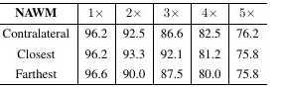
Conclusion: Our main goal in this paper was to study the NAWM variability by evaluating the impact of location and size on the distinction of normal from pathological regions by using texture analysis and a LDA classifier. We found that increases in the size of the NAWM region decreased accuracy, while variation in NAWM location did not impact accuracy. Thus, the known variation in the MR signal intensity within the white matter does not effect the texture analysis effectiveness. Besides, larger NAWM regions should be avoided on methods that aim to distinguish WML from NAWM.
Table 1: Achieved accuracy rates (percentage)

References: [1] Wang, L. et al., IEEE International Conference on Information Acquisition, 2005; [2] Catalaa, I. et al., Radiology 216(2):351-5, 2000; [3] Lu, Q. et al., Imaging Network Ontario Symposium, 2014; [4] Woods, R. and Gonzalez, R. C., Digital Image Processing, 2000; [5] Duda, R. O., et al., Pattern Classification, 2001.

